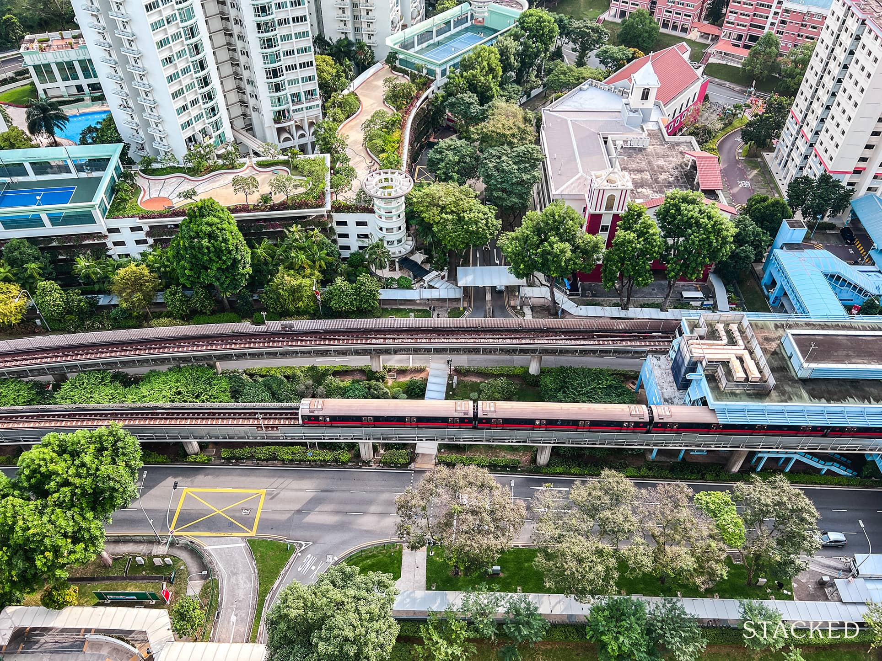

The Premium of Proximity: Quantifying the Impact of MRTs and Schools on HDB Resale Prices (2015–2025)

Author: Ng Shi Yun
Course: Data Analytics Capstone
Date: February 2026
Contents
1. Executive Summary 3
2. Data Governance: Sources and Data Dictionary 4
2.1 Data Sources 4
2.2 Data Cleaning & Preprocessing 4
2.3 Comprehensive Data Dictionary 5
3. Advanced Feature Engineering: Spatial Data via OneMap API 9
3.1 Address Concatenation and Geocoding 9
3.2 Calculating Spatial Proximity 9
4. Exploratory Data Analysis (EDA): Uncovering Market Patterns 11
5. Data Preprocessing & Feature Engineering 16
5.1 Feature Correlation Analysis 16
5.1.1 Numerical Correlation Analysis 16
5.1.2 Amenities Correlation Analysis: The "Lifestyle" Value 18
5.2 Prevention of Data Leakage 20
5.3 Encoding Phase 1: Pre-Encoding Cleanup 20
5.4 Train-Test Split 20
5.5 Encoding Phase 2: Encoding Strategy 20
6. Predictive Modeling & Evaluation 22
6.1 The Five Predictive Models 22
6.2 Model Evaluation & Results 23
6.3 Model Validation & Visualizing Predictions 26
7. Conclusion & Recommendations 28
7.1 Conclusion: Answering the Problem Statement 28
7.2 Strategic Recommendations 29
7.3 Limitations and Future Work 29

1. Executive Summary
While traditional factors like flat size and lease decay establish the baseline value of an HDB flat, but resale prices often vary depending on how close the flat is to amenities like MRT stations and well-regarded primary schools.
The Core Problem
Buyers, sellers, and agents know that convenience adds value, but it’s hard to measure exactly how much. Is the effect steady, or does one amenity matter more than others when trade‑offs are involved?
Objective
This project aims to measure how much MRT and school proximity really affects HDB resale prices between 2015 and 2025. Using OneMap API to calculate precise distances and adjusting for inflation, the study builds a predictive model that better reflects how buyers value convenience and access to schools.
Methodology & Approach
The project utilized a robust data science pipeline analyzing over 200,000 historical HDB transactions:
- Spatial Engineering: The Singapore Land Authority’s OneMap API was utilized to geocode exact coordinates for every transaction, calculating precise walking distances to the nearest MRT stations, transit interchanges, and primary schools using the Haversine formula.
- Economic Normalization: To prevent a decade of inflation from skewing the spatial analysis, the Consumer Price Index (CPI) was used to convert all nominal transaction prices into inflation adjusted "2024 Dollars" (Real Price).
- Predictive Modeling: Multiple algorithms were evaluated. A Random Forest Regressor was selected as the optimal model due to its ability to capture non-linear, threshold based human buying behaviors (e.g., the sharp drop in value once a flat is beyond walking distance to an MRT).
Target Audience
- First time Homebuyers: clearer, data driven expectations when planning a budget.
- Property Analysts & Agents: insights into which amenities add the most value, helping them make better pricing decisions.

2. Data Governance: Sources and Data Dictionary
The primary dataset consists of over 200,000 historical HDB transaction records (2015–2025) sourced from Data.gov.sg.

2.1 Data Sources
- HDB Dataset
- MOE school dataset
- Top primary school reference
- How Primary 1 registration balloting works
- MRT list from LTA’s Public Transport page 2
- Bus stop
- Hawker Centers
- Parks
- Shopping malls
- CPI

2.2 Data Cleaning & Preprocessing
Initial data cleaning for EDA
- Drop Null rows: 5350 nulls were detected and their rows were dropped as those rows address are from 5 Jln Batu, 6 Jln Batu, 52 Kent Rd, 54 Kent Rd. Putting these addresses through one map API got back the wrong coordinates. Adding the estate name per OneMap, gave a Null value. Hence, these 214 rows were dropped.
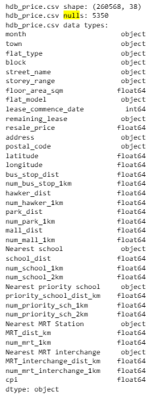
- Drop Duplicates: 335 sets of exact set of duplicates detected and dropped.
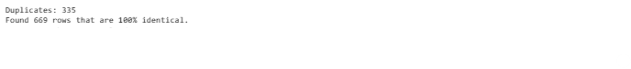
- Drop NIL values: 18 nil values in postal_code, and the correct postal code are entered in
- Outlier Not Remove: Transactions with high prices such as those in 3 room Flat types were not removed. Those outliers in 3 room flat types are Terrace flat model, with a high floor area (sqm).

2.3 Comprehensive Data Dictionary
The final engineered dataset consists of 46 distinct features. These variables incorporate raw historical data from Data.gov.sg, spatial proximity data engineered via the OneMap API, and macroeconomic adjustments (CPI).

Temporal & Location Identifiers
Variable | Data Type | Description
month | int32 | The month the resale transaction was registered.
year | int32 | The year the resale transaction was registered.
sale_date | datetime64[ns] | The exact datetime format of the transaction month/year.
town | object | The HDB town or estate (e.g., Bedok, Tampines).
address | object | Concatenated string of block and street name.
block | object | The specific block number of the HDB flat.
street_name | object | The street where the HDB block is located.
postal_code | object | The 6 digit Singapore postal code.
latitude | float64 | Engineered spatial latitude coordinate (via OneMap API).
longitude | float64 | Engineered spatial longitude coordinate (via OneMap API).

Flat Characteristics
Variable | Data Type | Description
flat_type | object | Broad categorization of the flat (e.g., 4 ROOM, 5 ROOM).
flat_model | object | Specific design model (e.g., Model A, Maisonette, DBSS).
flat_type_model | object | Engineered concatenated feature of type and model.
floor_area_sqm | float64 | Total internal floor area of the flat in square meters.
storey_range | object | The floor level band (e.g., 04 TO 06).
mid | float64 | Engineered numeric midpoint of the storey range (e.g., 5).
lease_commence_date | datetime64[ns] | The date the 99 year lease officially began.
remaining_lease | object | Time remaining on the lease at the point of sale.
hdb_age | int32 | Engineered age of the flat at the time of transaction.

Engineered Spatial Features (Proximity & Amenities)
Variable | Data Type | Description
Nearest MRT Station | object | Name of the closest MRT station.
MRT_dist_m | float64 | Distance to the nearest MRT station in meters.
num_mrt_1km | float64 | Count of MRT stations within a 1km radius.
Nearest MRT interchange | object | Name of the closest MRT interchange.
MRT_interchange_dist_m | float64 | Distance to the nearest MRT interchange in meters.
num_mrt_interchange_1km | float64 | Count of MRT interchanges within a 1km radius.
Nearest school | object | Name of the closest School.
school_dist_m | float64 | Distance to the closest School in meters.
num_school_1km | float64 | Count of Schools within a 1km radius.
num_school_2km | float64 | Count of Schools within a 2km radius.
Nearest priority school | object | Name of the closest top Primary School.
priority_school_dist_m | float64 | Distance to the closest top Primary School in meters.
num_priority_sch_1km | float64 | Count of top Primary Schools within a 1km radius.
num_priority_sch_2km | float64 | Count of top Primary Schools within a 2km radius.
bus_stop_dist_m | float64 | Distance to the nearest bus stop in meters.
num_bus_stop_1km | float64 | Count of bus stops within a 1km radius.
hawker_dist_m | float64 | Distance to the nearest hawker centre in meters.
num_hawker_1km | float64 | Count of hawker centres within a 1km radius.
mall_dist_m | float64 | Distance to the nearest shopping mall in meters.
num_mall_1km | float64 | Count of shopping malls within a 1km radius.
park_dist_m | float64 | Distance to the nearest park in meters.
num_park_1km | float64 | Count of parks within a 1km radius.

Financial Metrics & Target Variables
Variable | Data Type | Description
cpi | float64 | Consumer Price Index value for the transaction month.
resale_price | float64 | Raw, nominal transacted price of the HDB flat.
resale_price_per_sqm | float64 | Calculated nominal price divided by floor area.
real_price | float64 | Primary Target: Inflation adjusted resale price using CPI.
real_price_per_sqm | float64 | Inflation adjusted price per square meter.

3. Advanced Feature Engineering: Spatial Data via OneMap API
The raw dataset lacks the geographic coordinates required to analyze proximity. A data enrichment pipeline was developed using Python and the Singapore Land Authority’s OneMap API.

3.1 Address Concatenation and Geocoding
The block and street name columns were concatenated into a single address string. A Python script iterated through unique addresses, sending HTTP GET requests to the OneMap API to retrieve exact latitude and longitude coordinates. API rate limits were managed using time delays and batch processing.

3.2 Calculating Spatial Proximity
With coordinates acquired, the spatial distance to the nearest MRT and Primary School was calculated using the Haversine formula, which accounts for the spherical shape of the Earth to provide an accurate distance.
The Haversine formula is an equation from spherical trigonometry that calculates the great-circle distance between two points on the surface of a sphere, given their longitudes and latitudes. It is widely used in navigation and GPS systems due to its accuracy for most Earth-based distances.

The formula is:
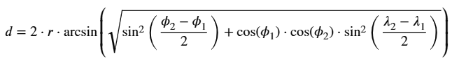

Implementation Steps
- Convert Coordinates to Radians: The latitude and longitude data, typically in decimal degrees, must be converted to radians using np.radians().
- Initialize the BallTree: Create an instance of BallTree and set the metric parameter to 'haversine'.
- Perform Queries: Use the query_radius() methods to find nearest neighbors or points within a specific radius.
- Convert Output Distances: The distances returned are in radians. Multiply by the Earth's radius (6371 km) to get distances in a familiar unit.
3.3 Economic Normalization: Adjusting for Inflation (The "Base Year" Method)
Because the dataset spans ten years (2015–2025), comparing raw, nominal transaction prices directly would introduce economic distortion due to inflation. To isolate the true "proximity premium," the target variable (resale_price) was normalized into a new feature: real_price.
The Economic Rationale
By using the Consumer Price Index (CPI) to adjust for the changing value of the Singapore Dollar, the model is trained to learn the underlying property trends independent of general macroeconomic inflation. This crucial step allows the model to capture the natural supply-and-demand cycles of the real estate market, rather than simply tracking the inflation movement throughout the years.
Methodology
This normalization was achieved using CPI data sourced from the Singapore Department of Statistics (SingStat). Statistical agencies set a specific "Base Year" where the CPI is exactly 100; currently, Singapore uses 2024 as the Base Year (2024 = 100). Every transaction in the dataset was converted into "2024 Dollars" using the standard economic formula:
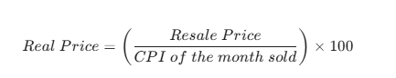
The Practical Impact
By applying this formula, historical prices are re-weighted to reflect modern purchasing power:
- A flat sold in 2015 for $400,000 (when the CPI was ~98) is adjusted slightly upward.
- A flat sold in 2025 for $600,000 (when the CPI was ~115) is adjusted downward.
This ensures an equitable, apples-to-apples comparison across the entire decade before any Exploratory Data Analysis or predictive modeling takes place.

4. Exploratory Data Analysis (EDA): Uncovering Market Patterns
Before model construction, EDA was conducted to identify trends and collinearity.
- Target Variable Distribution: The resale price distribution is right skewed. The majority of transactions cluster between $400,000 and $600,000, with a long tail extending toward million dollar pinnacle flats.
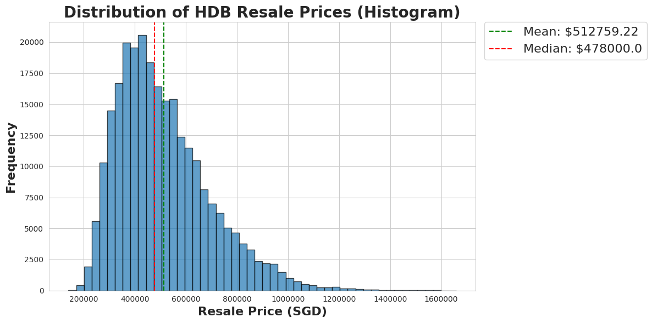
- The Space Premium: There is a strong positive linear correlation between floor area and price. However, the rate of price increase per square meter is noticeably steeper in Mature Estates compared to Non-Mature Estates.
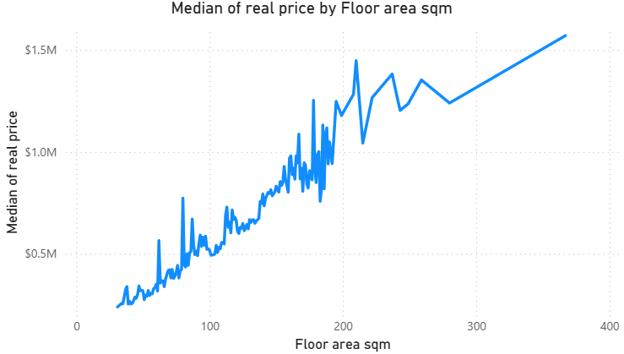
- Flat Types Floor area sqm: Multi Generation have the highest Median Floor Area, and 1 room flat types have the lowest Median Floor Area.
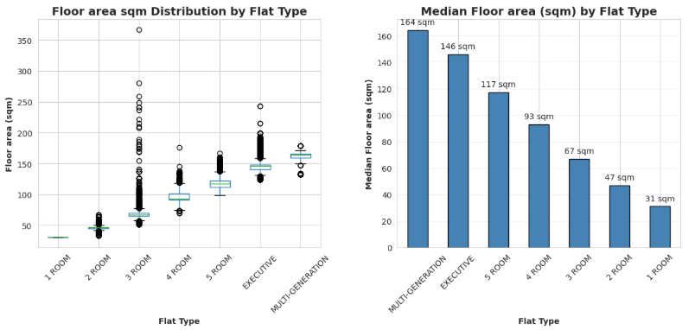

- 3 room flat types have the highest outliers: 3 room flat types have outliers where their floor area is more than the supposedly larger flat types. After further investigations, these outliers belongs to 3 room Terrace. These super large 3 room Terrace flats are special flats built in 1970s.



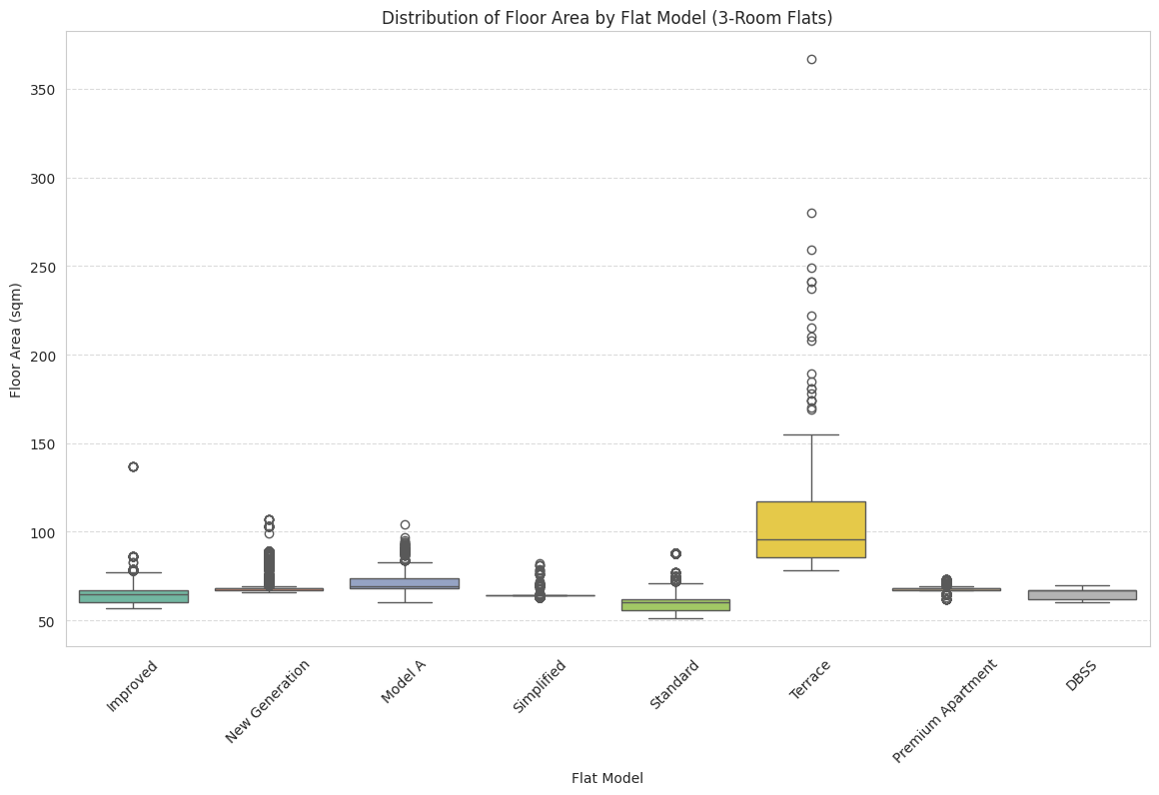

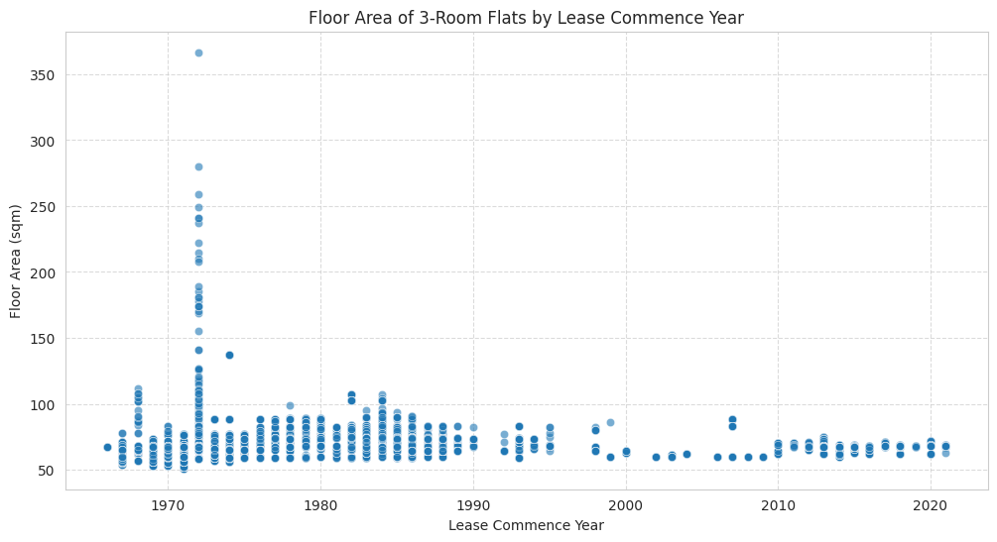

- The Lease Decay Effect: Older flats tend to sell at a lower price compared to newer flats due to lease decay
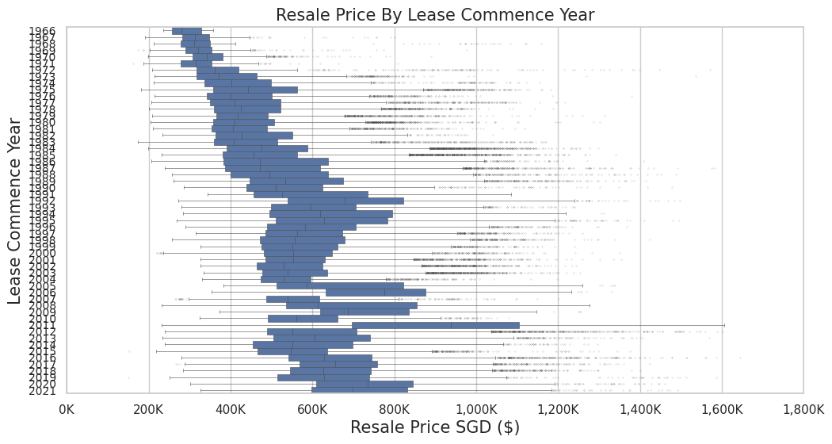

5. Data Preprocessing & Feature Engineering
Before training the predictive models, the data was clean and reprocessed to prevent artificial performance inflation. The features were also processed for the specific models that will be used.

5.1 Feature Correlation Analysis
Prior to data reprocessing, correlation heatmaps were utilized to identify the linear relationships between independent variables. This step is critical for identifying multicollinearity allowing for the safe removal of redundant features.

5.1.1 Numerical Correlation Analysis
This basic correlation heatmap was generated to evaluate the linear relationships (Pearson’s r) between all numerical features and the target variable (resale_price).
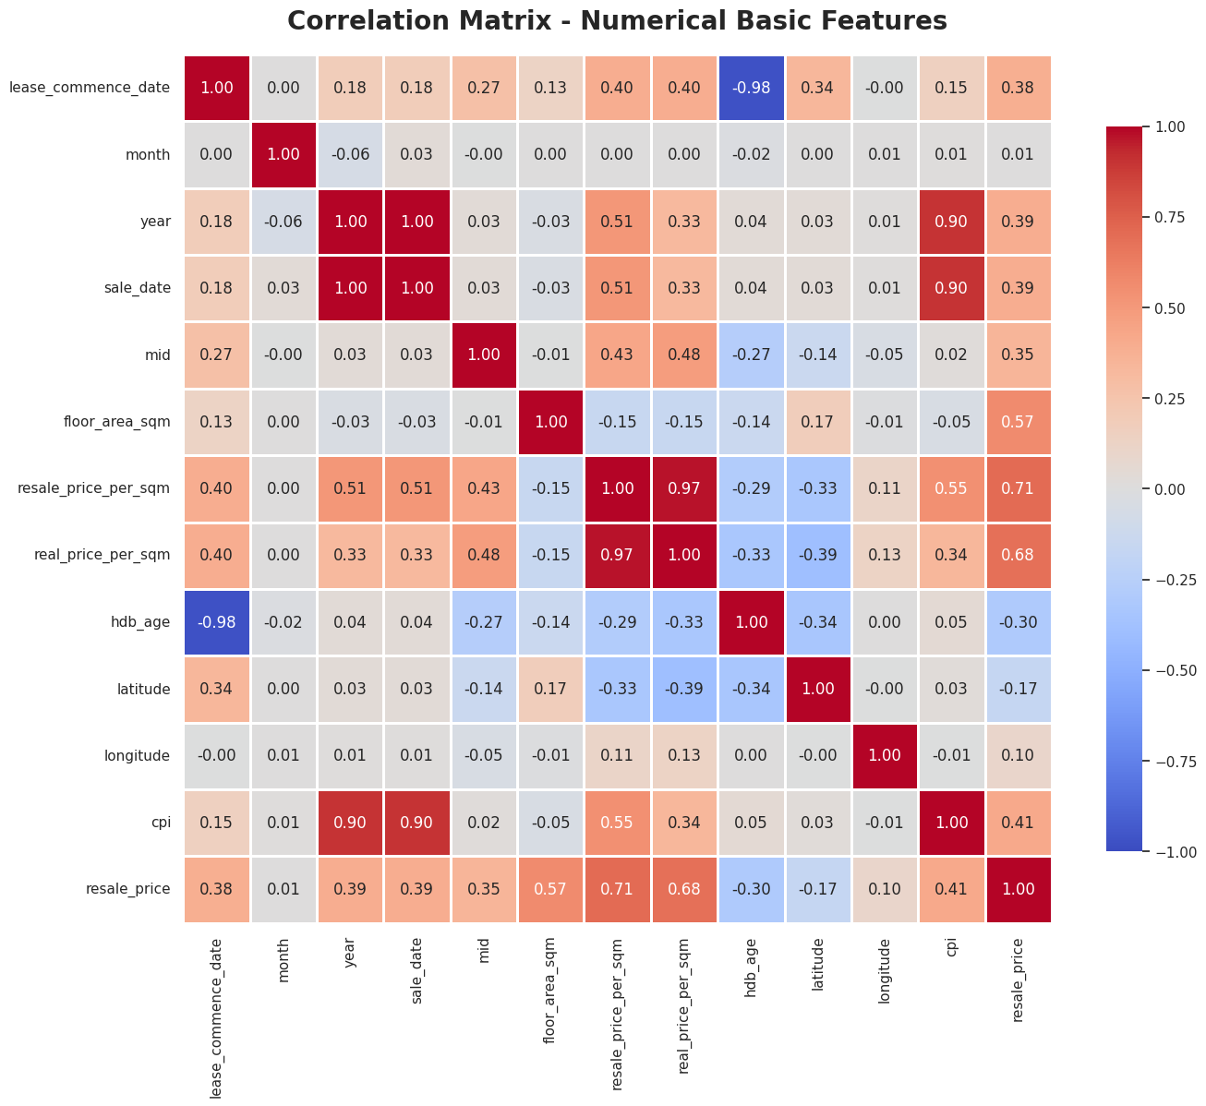
1. Strongest Positive Correlations
- Price per SQM Metrics (0.68 to 0.71): resale_price_per_sqm (0.71) and real_price_per_sqm (0.68) exhibited the highest mathematical correlation. However, because these are derived directly from the target variable, they were immediately flagged for removal (see Section 5.2) to prevent data leakage.
- Size (floor_area_sqm | 0.57): Confirms the foundational real estate assumption that larger flats command higher absolute prices.
- Macro-Economics (cpi | 0.41): Demonstrates that as the consumer inflation rate rises, nominal HDB resale prices rise concurrently.
- Temporal Trends (month & year | 0.39): Indicates a general upward trajectory in the market; more recently sold flats generally fetch higher prices.
- Lease Freshness (lease_commence_date | 0.38): Newer flats with longer remaining leases hold higher market valuations.
- Floor Level (mid | 0.35): Confirms the market's "high floor premium," where higher storey levels correlate with higher transacted prices due to better views and privacy.

2. Strongest Negative Correlations
- Depreciation (hdb_age | -0.30): Shows an inverse relationship where older flats transact at lower prices, directly reflecting the financial impact of the 99 year lease decay.
- Geography (latitude | -0.17): A negative correlation with latitude mathematically captures Singapore's geographical pricing divide; flats located further South (lower latitude, closer to the Central Business District) are generally more expensive than those located further North.

5.1.2 Amenities Correlation Analysis: The "Lifestyle" Value
Following the basic features, a secondary correlation heatmap was generated specifically to isolate the linear impact of the engineered spatial amenities (e.g., MRTs, schools, malls, and parks) on the resale_price.
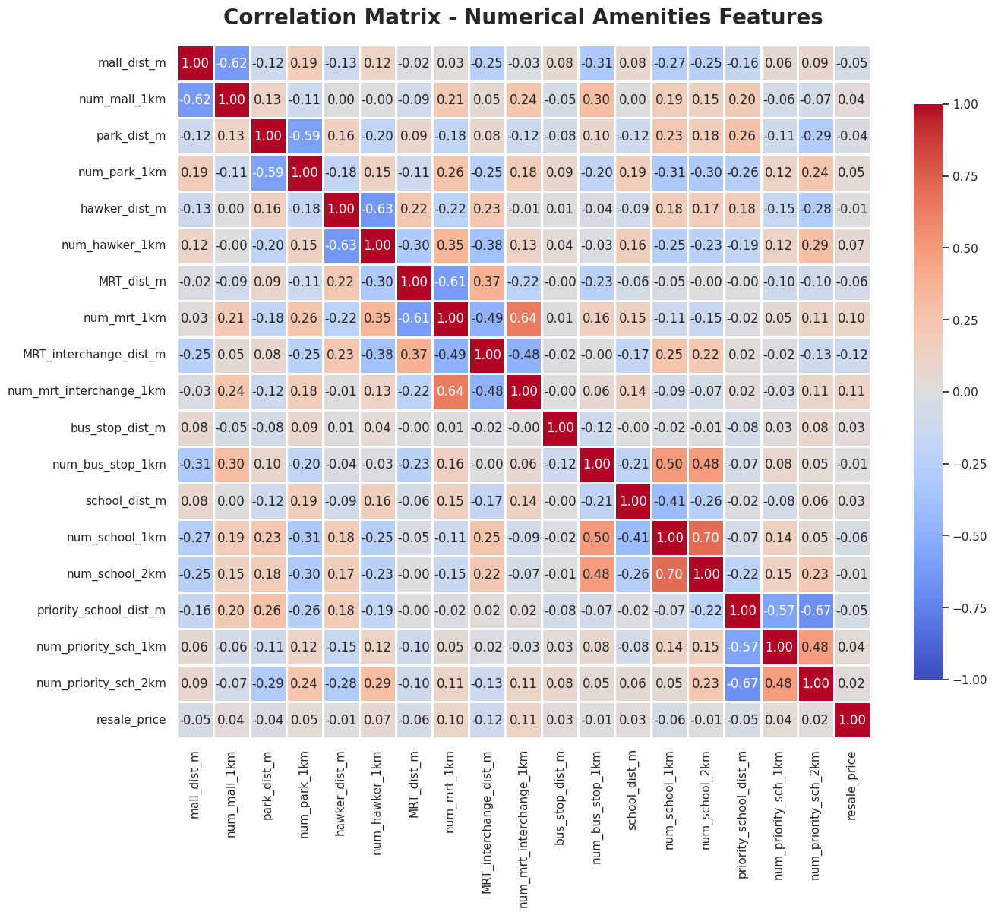
General Observation: No single factor stands out as the dominant driver
Most individual amenities exhibit a very weak direct linear correlation with the resale price, with almost all r fall between -0.12 and +0.11. This suggests that a single spatial factor, like being near a mall or a school, does not dictate the price in isolation. Instead, the "lifestyle value" of a location is driven by a complex combination of these factors, interacting with the basic flat attributes (size, age, and floor level).
1. Strongest Positive Correlations (Volume of Amenities)
- Number of MRT Interchanges (+0.11) & MRT Stations (+0.10): Having multiple transit options within a 1km radius is the most consistent spatial "value add." Proximity to major transit hubs (Interchanges) exerts the strongest positive correlation price among all amenities.
- Number of Hawker Centres (+0.07): A minor positive correlation, indicating that localized "foodie" convenience and mature estate infrastructure add supplementary value to a flat.
2. Strongest Negative Correlations (Distance to Amenities)
(Note: A negative correlation with distance means that as the distance decreases (get closer) the price increases.)
- MRT Interchange Distance (-0.12): This represents the strongest spatial relationship in the dataset. The closer a flat is to a major transport interchange, the higher the resale price tends to be.
- Mall Distance (-0.05): A very slight negative correlation. Being closer to a shopping mall exerts a tiny upward pressure on the price, though it is noticeably weaker than the transport effect.
3. The "Surprise" Neutral Correlations
- Priority Schools (-0.05 to +0.04): Whether a flat is near an elite priority school, or has several nearby, shows almost no linear impact on the price across the broader dataset. (As noted in Section 6, this premium is highly conditional and only activates for specific flat sizes within a strict 1km radius, which a simple linear correlation cannot capture).
- Parks (-0.04 to +0.05): Proximity to green spaces shows a negligible relationship with the resale price, indicating that Singaporean homebuyers prioritize transport and food convenience heavily over park access.
Conclusion: Justification for Advanced Modeling
Because the individual linear correlations for amenities are universally low (below 0.2), it mathematically proves that a Multiple Linear Regression model relying on these features will be highly inaccurate. The data explicitly demands an algorithm capable of combining these weak individual signals, like Random Forest, to capture the true, non-linear lifestyle value of a location.

5.2 Prevention of Data Leakage
Data leakage occurs when a model is trained with features that inadvertently contain the target variable (the "answer"), which creates a falsely inflated accuracy score. Before proceeding to the train-test split, the following derived columns were permanently dropped from the training set:
- resale_price_per_sqm
- real_price
- real_price_per_sqm

5.3 Encoding Phase 1: Pre-Encoding Cleanup
Machine learning algorithms require clean, numerical inputs. A general cleanup phase was applied uniformly across the dataset:
- Parsing Messy Text (Lease Decay): The remaining_lease column originally contained inconsistent string formats (e.g., "85 years 03 months"). This was parsed into a single, continuous float64 representing total decimal years (e.g., 85.25) to allow the models to calculate continuous lease decay.
- Handling Datetime Variables: Models cannot natively process plain text or raw datetime stamps. Consequently, sale_date and lease_commence_date were dropped. The temporal variance was successfully retained through the extraction of month (1-12), year, and the engineered hdb_age feature.
- Redundancy & Dimensionality Reduction: * storey_range was dropped in favor of the engineered mid feature, which provides the model with a clean numerical midpoint of the floor level.
- flat_type and flat_model were dropped as their combined variance is fully captured by the engineered flat_type_model column.
- address and postal_code were dropped due to extreme cardinality (too many unique values), with spatial positioning handled instead by latitude, longitude, and town.

5.4 Train-Test Split
Following the general cleanup, the dataset was partitioned into a training set and a testing set. It is an essential best practice to perform this split before applying mathematical encoding or scaling to ensure that no information from the testing data "leaks" into the training encoders.

5.5 Encoding Phase 2: Encoding Strategy
Different algorithms require entirely different data structures to function properly. The encoding strategy was divided based on the specific mathematical requirements of the models:
A. Linear Regression (The "Math" Approach) Linear regression calculates coefficients based on distance and scale. It will fail or produce skewed results if features are not on the exact same scale, or if it misinterprets categorical text as ranked numbers.
- One Hot Encoding (OHE): Categorical variables like town must be One Hot Encoded. If simple label encoding is used (e.g., Ang Mo Kio = 1, Bedok = 2), the linear equation will mathematically assume that Bedok is "greater than" Ang Mo Kio, which is logically false. OHE creates binary columns (0 or 1) for each town to prevent arbitrary ranking.
- Feature Scaling: Because features like distance_to_mrt are measured in thousands (meters) and hdb_age is measured in tens (years), the data must be standardized. Without standard scaling, the linear model would improperly assign massive weight to the distance simply because the raw numbers are larger.
- Drop High Cardinality Categorical features: For features such as Nearest MRT Station, Nearest school, and Nearest priority school, One hot encoding would create over 100 columns and ruin model performance. These can be safely dropped since there are distance based features like MRT_dist_m available
B. Random Forest (The "Tree" Approach) Because Random Forest is an ensemble of decision trees, it partitions data using threshold splits (e.g., hdb_age <= 10) rather than calculating mathematical distance.
- Label/Target Encoding: Random Forest handles categorical rankings efficiently and does not require One Hot Encoding. In fact, using OHE on a variable with many categories (like town) creates a highly sparse dataset that dilutes the predictive power of individual trees. The recommended strategy is Ordinal (Label) Encoding. This process assigns a unique integer ID to each string (for example, Bedok=1, Bishan=2), which decision trees handle perfectly without the need for complex one hot encoding.
- No Scaling Required: Because decision trees only care about the optimal threshold to split a node, they are not affected by the scale of the features. distance_to_mrt and hdb_age can remain in their original units without skewing the model's accuracy.

6. Predictive Modeling & Evaluation
To accurately quantify the "premium of proximity" and predict resale prices, a progressive modeling approach was adopted. Five distinct predictive models were built, trained, and evaluated. The objective was to find an algorithm that maximizes predictive accuracy while successfully handling the non-linear realities of Singapore’s real estate market.

6.1 The Five Predictive Models
1. Model 1: Dummy Regressor (Baseline / "The Simple Guesser")
Mechanism: This model completely ignores all engineered features and simply predicts the average (or median) resale_price for every single transaction.
Purpose: It serves as a strict "sanity check" baseline using the unscaled X_train dataset. If the subsequent machine learning models cannot beat the Dummy Regressor, the feature engineering process has failed.
2. Model 2: Original Linear Regression ("The Straight Line Guesser")
Mechanism: Uses basic input features to draw a single straight line of best fit. It operates on the mathematical assumption that if a "clue" (like floor area) increases, the price increases at a constant, linear rate.
3. Model 3: Log-Transformed Linear Regression ("The Curve Straightener")
Mechanism: Standard regression struggles with "skewed" data (where most flats are average-priced, but a few pinnacle flats are incredibly expensive). By applying a logarithmic transformation to the target variable (resale_price), this model "straightens out" exponential curves, allowing the algorithm to handle non-linear market extremes more effectively.
4. Model 4: Ridge Regression ("The Careful Straight Line Guesser")
Mechanism: Similar to standard linear regression but introduces L2 regularization (a "safety brake"). This penalizes overly large coefficients, preventing the model from becoming too obsessed with any single feature and helping it remain accurate on unseen test data.
5. Model 5: Random Forest Regressor ("The Expert Committee")
Mechanism: An ensemble learning method that utilizes hundreds of individual "Decision Trees" (conditional flowcharts). Each tree makes a prediction, and the forest averages their votes to determine the final price.
Purpose: Highly effective at capturing complex, multi-variable spatial patterns (e.g., the threshold effect of being exactly 500m from an MRT) that a straight linear line will miss.

6.2 Model Evaluation & Results
The models were evaluated based on their R-squared ( R² ), Root Mean Squared Error (RMSE) and Mean Absolute Error (MAE).
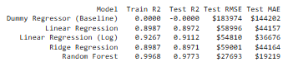

1. The Baseline (Dummy Regressor)
- The Verdict: Zero predictive power.
- Insight: With an R² of 0.0000, the massive errors (RMSE of $183,974) provide a "ceiling" for how bad predictions can be. It proves the necessity of our engineered features.
2. Linear & Ridge Regression
- The Verdict: Strong baseline performance, but Ridge is unnecessary.
- Insight: Both models achieved an identical R² of 0.8972. This suggests that the baseline relationship between features and the target is significantly linear. Because Ridge regularization did not change the outcome, it indicates there is no extreme multicollinearity plaguing the dataset.
3. Linear Regression (Log Transformed)
- The Verdict: A noticeable step up from standard linear models.
- Insight: By using the log of the target variable, the R² jumped to 0.9112 and the MAE dropped significantly from ~$44,000 to $36,676. This confirms the EDA findings: the transaction data has a right-skewness that the log-transform successfully "tamed."
4. Random Forest (The Winner)
- The Verdict: Exceptional performance.
- Insight: This model outperformed all others by a massive margin. With an R² of 0.9773, it successfully explains nearly 98% of the variance in the HDB resale market. The MAE indicates that, on average, the model's predictions are only off by about $19,219, a highly acceptable margin of error for properties valued at half a million dollars.

6.2.1 Feature Importance: The Top 15 Drivers of HDB Prices
While the Random Forest model utilizes all engineered variables to make its final predictions, its built-in Feature Importance metric (Mean Decrease in Impurity) reveals that the model's predictive power is heavily concentrated in a top tier group of 15 features.
By analyzing this ranking, we can quantitatively prove which factors truly drive HDB resale valuations in Singapore:
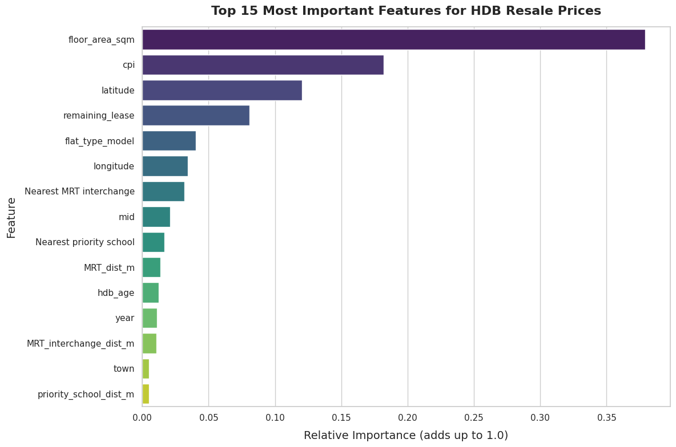

Analysis of Top Drivers & The Problem Statement
1. The Baseline: Size and Inflation The model correctly identifies floor_area_sqm as the ultimate determinant of an HDB flat's price. However, the presence of cpi (Consumer Price Index) at Rank 2 is a profound insight. It mathematically proves that over the 2015–2025 decade, macroeconomic inflation was a stronger driver of nominal resale prices than almost any localized spatial amenity.
2. The Transport Premium: Interchanges Over Standard Stations Addressing the core problem statement, the model reveals a highly nuanced view of transport convenience. Noticeably, Nearest MRT interchange (Rank 7) ranks higher than standard MRT_dist_m (Rank 10) and MRT_interchange_dist_m (Rank 13). This indicates the market heavily prioritizes flats connected to major transit hubs (where multiple lines intersect, accompanied by integrated malls) rather than just being near any standard MRT station.
3. The Education Premium: Elite Schools Matter The model confirms that the "school premium" exists, but it is highly specific. Nearest priority school (Rank 9) and priority_school_dist_m (Rank 15) made the top 15, while standard primary schools did not. This proves that buyers are not just paying for proximity to any school; they are paying a strict premium to secure Phase 2C balloting advantages for historically elite, oversubscribed institutions.
4. Geography Dominates "Town" Names Interestingly, precise geographical coordinates (latitude at Rank 3, longitude at Rank 6) vastly outrank the categorical town label (Rank 14). This suggests that the model learned the underlying spatial map of Singapore (e.g., recognizing that moving South toward the CBD increases price) rather than just relying on arbitrary estate borders, showcasing the power of the OneMap API spatial engineering.

6.3 Model Validation & Visualizing Predictions
To ensure the models were not overfitting, visual diagnostics were conducted.

- Prediction vs. Actual Plot (Scatter Plot): Plotted the predicted prices against the actual transacted prices to visually confirm the tight clustering along the axis of perfect prediction.
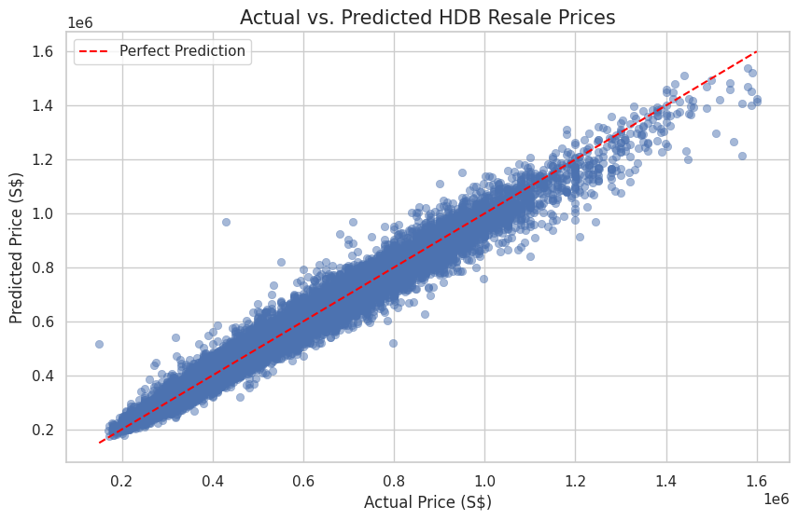

- Residual Plot: Generated to ensure errors were randomly distributed across all price points, confirming the model does not become progressively more inaccurate for million dollar flats.
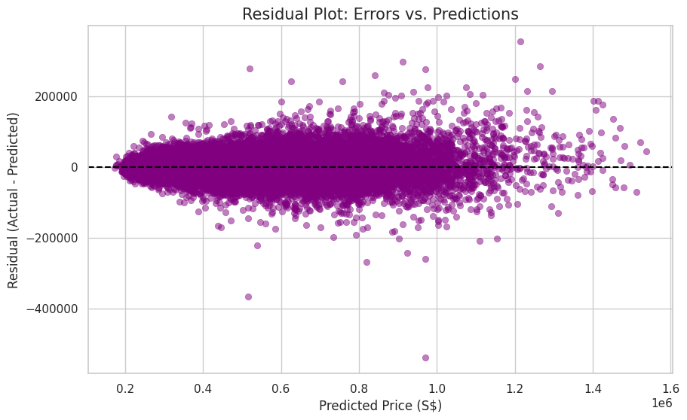

7. Conclusion & Recommendations
The objective of this project was to move beyond traditional linear assumptions and accurately quantify how Singaporean homebuyers value transport convenience and education access. By engineering precise spatial data via the OneMap API and neutralizing inflation via CPI adjustments, the Random Forest Regressor (R² = 0.9773, MAE = $19,219) successfully mapped the complex, non-linear realities of the HDB resale market.

7.1 Conclusion: Answering the Problem Statement
The data conclusively proves that proximity to MRTs and schools affects HDB prices, but the market's application of this premium is highly selective:
- The Transit Hub Dominance: Buyers do not value all MRT stations equally. Proximity to an MRT Interchange is a vastly stronger price driver than proximity to a standard MRT station, reflecting a high willingness to pay for multiline connectivity and integrated commercial amenities.
- The Elite Education Premium: The "school premium" is not universal. General primary schools exert negligible influence on market prices. However, strict inclusion within the 1km radius of an elite, oversubscribed primary school acts as a massive price multiplier, driven entirely by the MOE's Phase 2C distance based balloting rules.
- Macro-Economics vs. Micro-Geography: While spatial proximity is crucial for localized valuations, the model's ranking of CPI as the second most important feature overall demonstrates that broad macroeconomic inflation plays a heavier role in nominal price growth than any single neighborhood amenity.

7.2 Strategic Recommendations
For Prospective Homebuyers:
- The "Value" Zone: Buyers seeking transport convenience without the premium price tag should target flats located between ~800m and 1km from standard MRT stations. Within this band, the market applies a "proximity penalty" (reducing the asking price), yet the actual physical inconvenience (a 10 to 12 minute walk) remains minimal.
- Avoiding the Premium: Buyers without or not planning to have children can avoid purchasing family sized flats (4-room or 5-room) within a 1km radius of elite priority schools. Purchasing in these zones means competing against parents willing to overpay for Phase 2C balloting advantages, resulting in an inflated "education premium" the buyer does not need.
For Property Agents and Sellers:
- Hyper Targeted Marketing: Marketing materials should explicitly differentiate between standard MRTs and Interchanges. If a flat is within 500m of an Interchange or strictly within 1km of a top tier primary school, these metrics should be the absolute focal point of the listing, as the model proves these are the market's most valued spatial thresholds.
- Leveraging Verticality: Because the model ranks floor level (mid) higher than several spatial amenities, agents selling high floor units in less accessible (Non-Mature) estates should confidently price their units at a premium as the market heavily values vertical privacy and views.

7.3 Limitations and Future Work
While the model is highly accurate, it operates within certain boundaries that future iterations should address:
- Qualitative Unit Features: The dataset cannot account for interior renovation quality, or unblocked views, which can swing individual transactions by tens of thousands of dollars.
- Impending Education Policy Shifts: Historically, proximity to the nine specific primary schools offering the Gifted Education Programme (GEP) commanded extreme price premiums. With the MOE discontinuing the GEP in its current form from 2027 in favor of a decentralized approach, future models must monitor whether the "elite school premium" dilutes and distributes more evenly across the broader HDB market.
- Macro-Economic Shocks: The current model normalizes inflation but does not predict broader economic shocks. Future models should integrate government cooling measures (e.g., ABSD adjustments) and prevailing mortgage interest rates (e.g., SIBOR/SORA) to forecast market volume alongside price.

